
The Sun, Earth and Moon
ICT Task 3

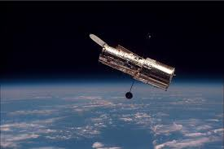

Picture: Hubble telescope orbiting the earth.

Learning Objective:

Success Criteria:

Warm-up Task:

https://www.space.com/36316-the-most-amazing-space-stories-of-the-week.html

https://www.space.com/underwater-rover-testing-for-icy-moons.html

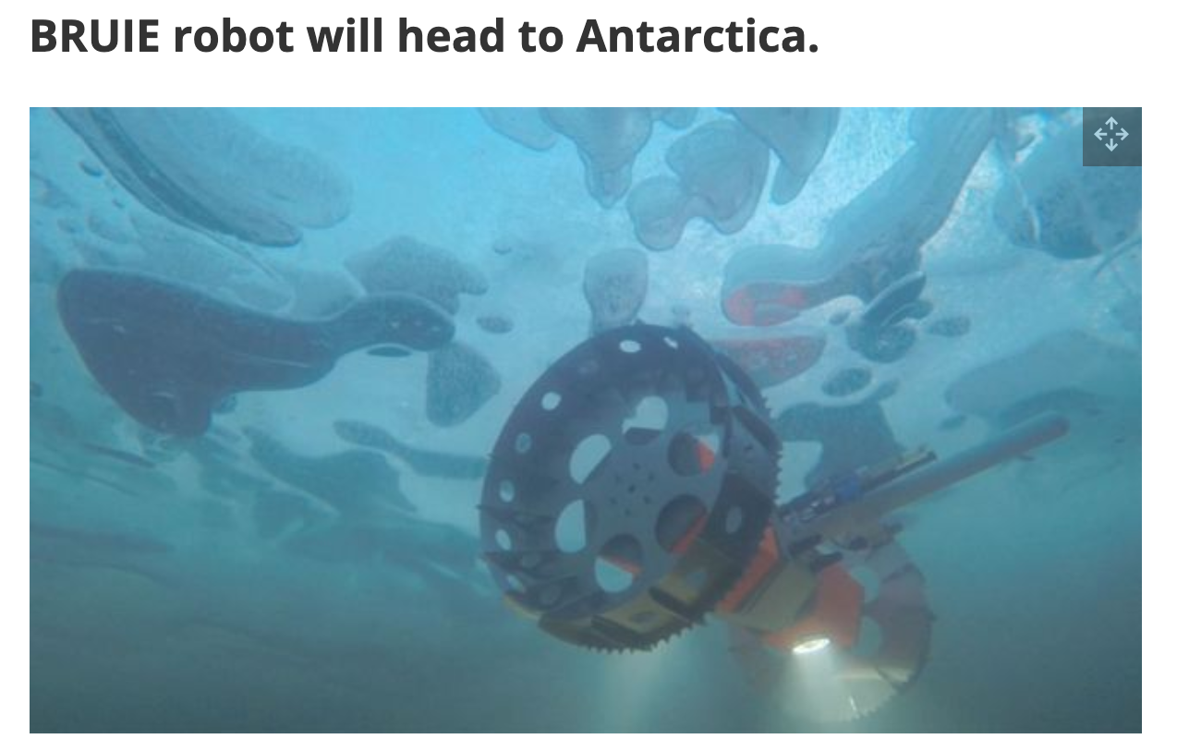

Conduct some further research:

How is NASA going to try and find life on other planets?

Task 1:

https://phet.colorado.edu/sims/html/gravity-and-orbits/latest/gravity-and-orbits_en.html

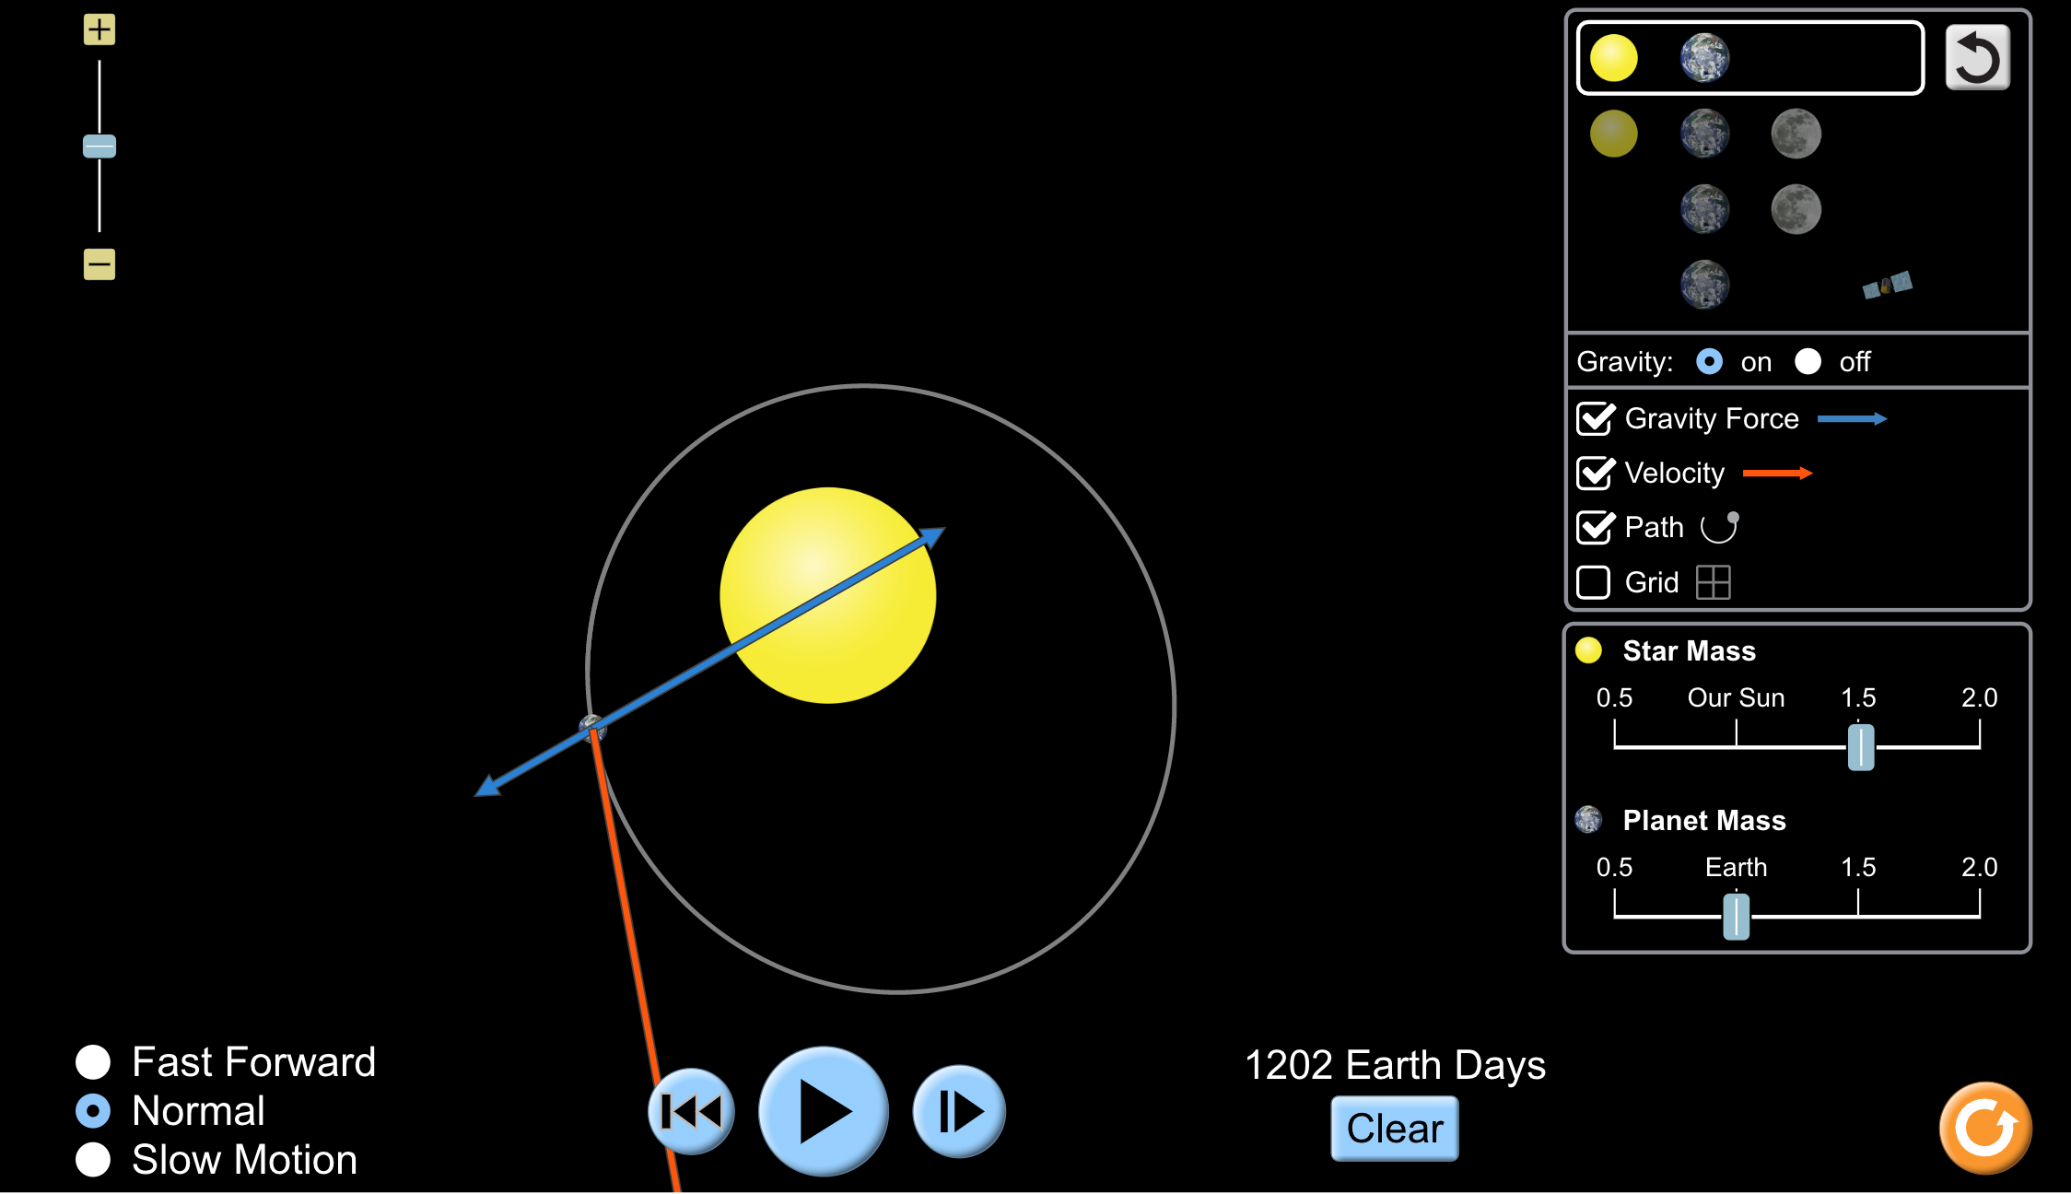

Instructions:
Using the key on the right-hand side of the screen, you can change the mass of the various objects whose orbits we are simulating.

Use this to model various simulations of orbits make sure you change between the scale and model modes.

If you turn gravity off…. Be sure to turn it back on quickly!

Part 1:
In the picture below, draw how the Earth and the Moon move.

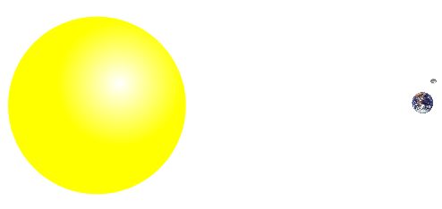

Part 2: Understanding Gravity
- For the Sun and Earth system:
  - Draw the path of the Earth with Gravity ON and Gravity OFF

GRAVITY ON GRAVITY OFF

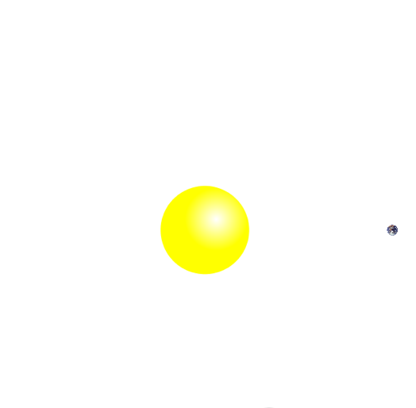

  - Why do you think gravity is important?

- Explore the simulation to find out how you can change the force of gravity and observe what happens.

Questions

What observations did you make about the path the Earth takes around the sun? Moon and Earth?

What did you notice when you turned off gravity in the simulation?

What could you vary in the simulation?

How could you change the time it took for the earth to orbit the sun?

If the mass of either object involved increases, what happens to the gravitational force arrows?

Task 3:
http://www.scootle.edu.au/ec/viewing/L696/L696/index.html#

Instructions: Read through the simulation and answer questions 1 – 10

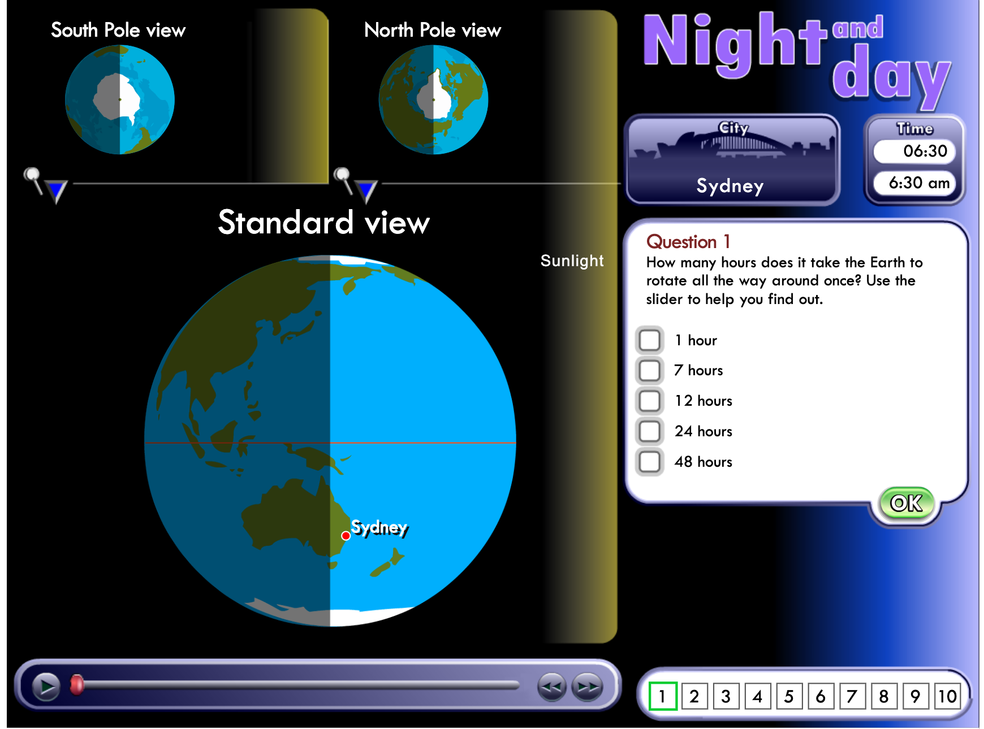

Task 4:

Research possible impacts of the Moon no longer orbiting the earth.

Task 5:
What can we learn from the 2019 solar eclipse?

